Software Engineering is the systematic approach to the development, operation and maintenance of software. Software Engineering is concerned with development and maintenance of software products.

The primary goal of software engineering is to produce the software with low cost. Software Engineering involves project planning, project management, systematic analysis, design, validations and maintenance activities.

The Software Development Life Cycle

Planning is an important factor in determining the success or failure of any software project. Good project planning will eliminate many of the mistakes that would otherwise be made, and reduce the overall time required to complete project. The software development life cycle is a series of steps used by professional software developers to plan a software project.

A generic software development life cycle consists of these steps:
- Analyse user requirements
- Design the program
- Code the program
- Document and test the system
- Operate and maintain the system
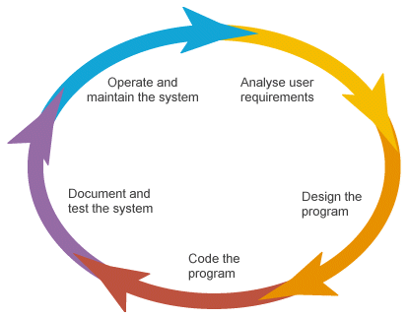

Software development life cycle is cyclic, meaning that last step (operate and maintain the system) will eventually lead back to the first step (analyse user requirements)

- Analysis of user requirements
During this stage, the problem is defined so that a clear understanding can be gained of what the system should do. Data collection should be done to obtain the clear picture of the problem by identifying, but not limited to, the following:
- what the input to the system are
- who input data to the system
- what form the data is in
- any validation is needed
- what the output should be
- what processing is done to produce the required outputs
- the operational parameters within which the system is expected to work
Data collection can be done through researching on existing systems, carrying out surveys and questionnaires and most commonly meeting with / interviewing the end user. Creating and providing the end users with a prototype (initial design) may be useful in helping them to clearly understand their requirements of the software.
If the new system is to replace an existing system, the problem may be defined in terms of the additional or enhanced functionality that is required.

- Program design
In this stage, a solution to the problem is designed by defining the data structures, algorithms and modular organization that will achieve each of the stated system objectives (defined in stage 1). In an object oriented design, data structures are the classes and their fields and methods. Algorithms are the logical sequences of steps that will achieve the functionalities of the methods. Modular organization is the relationship and interactions between the different classes. A complete UML diagram as well as the pseudo code of all methods are deliverables of this stage.

- Program coding
This stage, also known as the implementation stage, is where the data structures, algorithms and modular organization, defined in stage 2, are translated into a programming language. This stage tends to be the longest phase of the development life-cycle, but should be fairly straight-forward if stage 2 is done thoroughly. Implementation should be done with good programming style, e.g., easily readable, sufficient and appropriate comments, meaningful identifier names, consistent indentation scheme.

- Documentation and testing
The documentation of the program fulfills two main objectives. The first is to provide a technical reference to facilitate ongoing maintenance and development of the software itself. The second is to provide user documentation, i.e., a set of instructions that inform the user about the features of the software and how to use them. The aim of software testing is to find any errors (“bugs”) in the program, to eliminate those errors (“debugging”). Testing should be sufficiently rigorous to ensure that the software will function as expected under all foreseeable circumstances. Therefore, sample runs should test all possible branches of the program, use different sets of valid data (e.g. typical cases and boundary cases) as well as inappropriate and erroneous data.

- Operating and maintaining the system
Once the software is released and any necessary user training has been completed, it will be necessary to monitor the performance of the system over time to ensure that it is behaving as expected. The system will need to be maintained, and parts of it will need to be upgraded from time to time to handle evolving user needs to cope with new problems. Eventually, as the system ages, it may no longer be able to adequately cope with the demands of a growing number of users, take advantages of advances in hardware technology, or adapt to a constantly changing environment. When this time comes, the system will need to be decommissioned and replaced by a new system. Hence, the software development life cycle will begin again.

Source:
http://www.samsvb.co.uk/index.php?page=lesson&les=Lesson%2014

